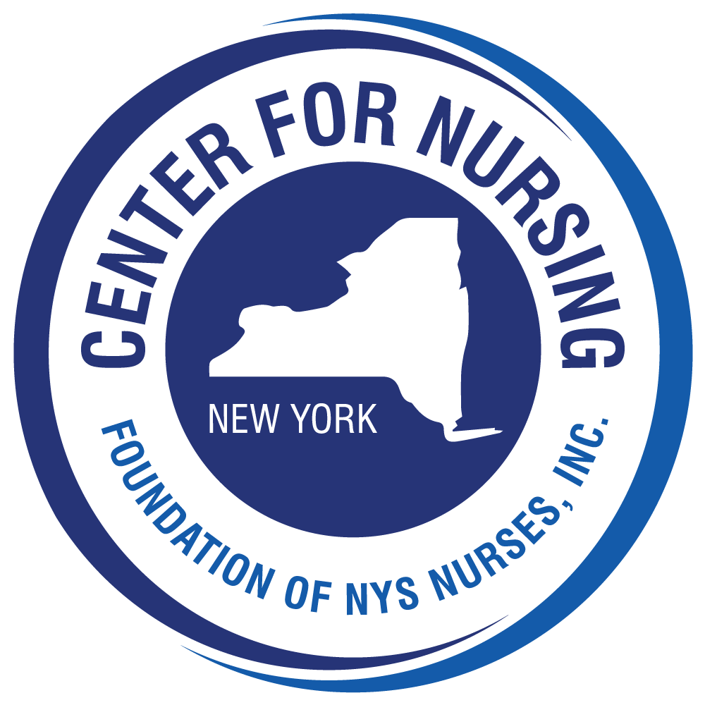

Call for Scholarship Applications!
The Center for Nursing at the Foundation of New York State Nurses, Inc.
is pleased to announce the

Nightingale Scholarship

A $5,000 scholarship will be awarded to a qualified high school senior
who is enrolled full time in a NYS accredited baccalaureate RN nursing program
beginning in the Fall 2024 semester post high school graduation.
Eligibility criteria, application packet documents and required forms are attached
or can be obtained from the Center for Nursing website (www.cfnny.org)
under the Scholarship section
For questions contact Deborah Elliott, Executive Director, Foundation of NYS Nurses
518-456-7858, ext. 129 or delliott@cfnny.org

Application deadline is July 1, 2024
The scholarship recipient will be notified of the award by September 1st. The scholarship will be presented at the Nightingale Gala taking place on Friday, October 18, 2024 at the Albany Marriott in Albany, NY. The scholarship recipient and two guests will be invited to attend the Gala as our guests.

The funding for this scholarship is made possible through sponsorship and support of the annual Nightingale Gala.

Foundation of New York State Nurses (FNYSN), established in 1975, is a 501(c)(3) organization whose is committed to supporting working professional nurses through mentoring, educational advancement and promoting research and evidence-based practice to drive excellence in care delivery.

Nightingale Award for a High School Senior
enrolled in a New York State baccalaureate RN Nursing Program

Purpose: To encourage high school students to consider a career as a professional registered nurse (RN)

Amount: Scholarship will be in the total amount of $5,000.
Scholarship will be awarded in 4 installments:
1st installment of $1,250 at the Nightingale Gala on October 18, 2024
2nd installment of $1,250 at the beginning of the second year
3rd installment of $1,250 at the beginning of the third year
4th installment of $1,250 at the beginning of the final year

Eligibility Criteria:
  - New York State residency
  - Acceptance into a NYS generic 4-year BSN nursing program accredited by the Accreditation Commission for Education in Nursing (ACEN) or the Commission on Collegiate Nursing Education (CCNE).
  - Full-time study
  - Graduating from a NYS high school with a minimum GPA of 3.0 or equivalent
  - Evidence of community service during their high school career
  - Maintaining a minimum of a 3.0 GPA during 4 year of a genetic BSN program

Applicants for the Nightingale Scholarship must complete the application face sheet, and submit all required documents of the application packet. (see below). Incomplete applications will not be reviewed. Any questions or requests for additional information, contact: Deborah Elliott, MBA, RN, Executive Director, Center for Nursing, Foundation of NYS Nurses, at 518 456-7858, Ext. 129 , delliott@cfnny.org.

Email or Mail completed application packet and all required documents to:
Nightingale Scholarship Program
Foundation of New York State Nurses
2113 Western Avenue
Guilderland, NY 12084
delliott@cfnny.org

Nightingale Scholarship Application Face Sheet
Applicant name___________________________

Home Address_____________________________________________________________________

Phone: Home or Cell ________________________Email __________________________________

High School ______________________________________________________________________

High School address________________________________________________________________

Nursing program ___________________________________________________________________

Nursing school address _____________________________________________________________

Start date _______________________ Expected graduation date___________________________

The following documents constitute the application packet and are required to be submitted with the application face sheet. Reference forms may be emailed or mailed separately.

- Two references (on reference form): One from a teacher or guidance counselor; the second reference from an adult supervisor from volunteer/community service.

- Copy of letter from the academic institution confirming your acceptance in a full time BSN nursing program for the Fall semester.

- Official transcript(s) from current high school stamped with the school's official seal and submitted in a sealed envelope.

- Essay, typed, one page double-spaced explaining why you are choosing to pursue a career in nursing and how this scholarship will help you achieve this goal.

- High school volunteer/community service activities form

Nightingale Scholarship Application Reference Form

Applicant name_________________________________________________________________

Name of reference provider________________________________________________________

Relationship to the applicant_______________________________________________________

Position_________________________Organization/Institution____________________________

Address_______________________________________________________________________

Telephone: _______________________ Email ______________________________________

Signature/Date _____________________________________________________________

- On a separate sheet of paper, please describe how in your relationship with the applicant you were able to assess/observe their aptitude for pursuing a nursing education.
- Please rate the applicant on the characteristics listed below using a scale with 5 being the highest and 1 being the lowest.

Qualifications | 5 | 4 | 3 | 2 | 1 | Comments
Leadership
Character/Integrity
Accountability/Dependability
Communication Skills/Oral and Written
Problem Solving/Judgment
Interpersonal Skills
Intellectual Potential
Creativity/Vision

Please email to delliott@cfnny.org or mail to Center for Nursing, 2113 Western Ave. Guilderland NY 12084

Nightingale Scholarship
High School Volunteer/Community service form

Community agency | Activities performed | Dates of service
Supervisor name & phone #:

Supervisor name & phone #:

Supervisor name & phone #:

Supervisor name & phone #:

Supervisor name & phone #:

*Include completed form in application packet

