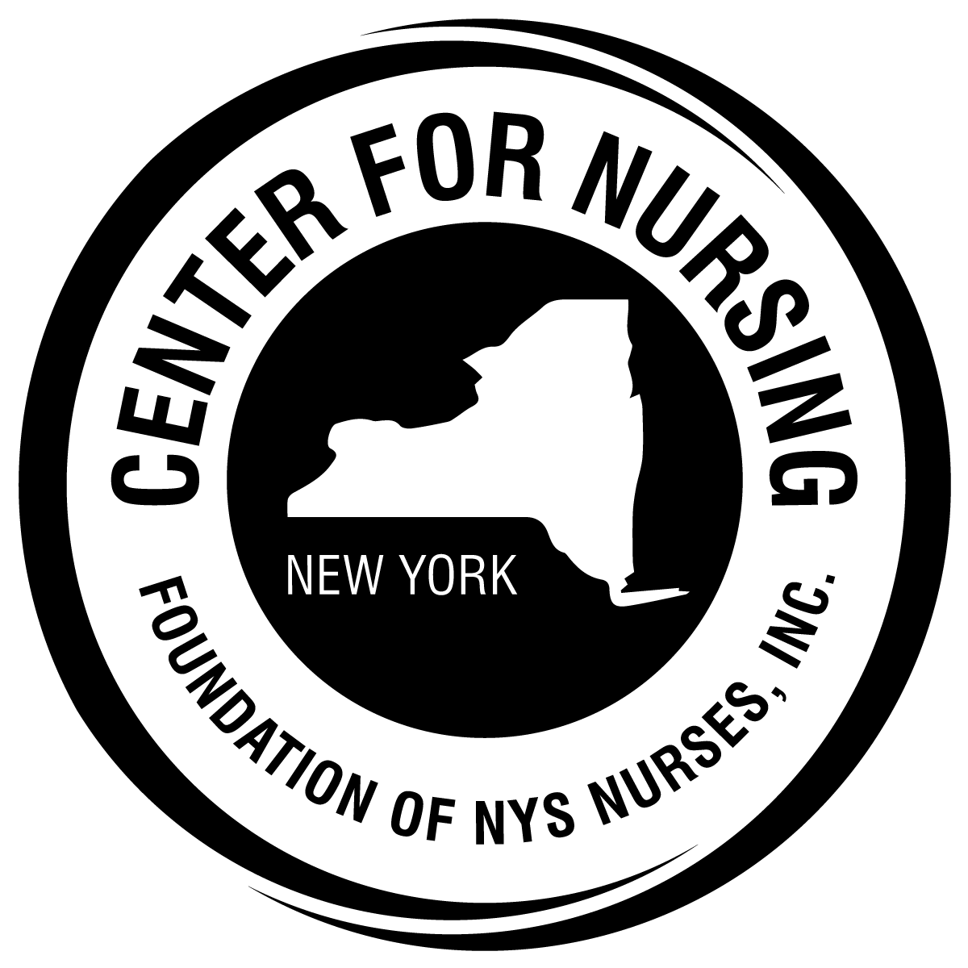

FOUNDATION of NEW YORK STATE NURSES
CATHRYNE A. WELCH
CENTER FOR NURSING RESEARCH

APPLICATION PACKET
For
The Mary J. Finnin Grant
for
Nursing Innovation in Oncology

Rolling application. Applications accepted at any time.
One scholarship will be awarded each calendar year.

This packet may be downloaded from the Foundation web site.
Widespread dissemination is encouraged and deeply appreciated.

Foundation of New York State Nurses

Cathryne A. Welch Center for Nursing Research
2113 Western Ave.
Guilderland, NY 12084
Tel: 518-456-7858
Fax: 518-452-3760
www.cfnny.org

Mary J. Finnin Grant for Nursing Innovation in Oncology

Introduction and Instructions for Applicants
The Foundation’s Cathryne A. Welch Center for Nursing Research aims to improve nursing science and practice by supporting the conduct of nursing research and dissemination of research findings. The Center takes great pride in offering the Mary J. Finnin Grant for Nursing Innovation in Oncology.
The funding for this grant is made possible by a generous donation from Mary J. Finnin and others.
Mary J. Finnin Grant for Nursing Innovation in Oncology

Award Intent: To assist a qualified registered professional nurse who is currently or interested in pursuing nursing innovation in the field of oncology.
Amount of Award: This is a one-time award totaling $7,500.

Eligibility and Use of Funds
To be eligible to apply for the Mary J. Finnin Grant, the applicant must:
- Hold licensure as a registered professional nurse in New York State;
- Have a baccalaureate or higher degree in nursing from a nursing program accredited by the Accreditation Commission for Education in Nursing (ACEN) or the Commission on Collegiate Nursing Education (CCNE); and
- Reside in and/or practice professional nursing in New York State.
Preference will be given to professional nurses who have a clinical mentor or advisor available to assist with the project.

Examples of how grant funds may be used:
- Researcher time, assistants (e.g., tape transcription)
- Travel expenses incurred while collecting data
- Photocopying
- Postage
- Equipment to support the data collection process (e.g., tapes, tape recorder)
- Participant reimbursement
- Poster development

Sample Ideas for the Mary J. Finnin Grant for Nursing Innovation in Oncology

- A study on the impact of a dedicated nurse in the Cancer center/Oncology unit who uses the Palliative Care trigger tool to identify patients who meet the criteria for Palliative Care. This nurse would then inform the oncologist and then set up an appointment with patient and family to discuss Palliative Care options in the clinic or community. Impact would include patient and family satisfaction, number of hospital admissions prevented for the patients who accept Palliative Care, and MD satisfaction with care provided.

- Development of a community education program on Advanced Care Planning to include the Conversation Project© and the 5 Wishes©. Impact could include number of attendees in total and the number of attendees who follow through with completion of the documents for advanced care planning.

- Data collection by the recipient on hospitalizations for patients on Palliative Care program versus those who are not but eligible for a program. Would require data collection using the Palliative Care Trigger tool – probably done retrospectively. Investigator would look at readmissions over a stated time period and those that might have been avoided with a Palliative Care intervention.

- The study may focus on number of patients in an oncology practice who have transitioned from Palliative Care to Hospice care with a length of stay on Hospice for more than 3 months. Data show many patients are referred to Hospice late in their illness and do not benefit as much from the hospice stay.

- A descriptive study of families whose loved one had a cancer diagnosis and had received Hospice care. This study could inform oncologists regarding referral to Hospice (or Palliative Care) and the benefits described by families.

Evaluation Criteria
Grant proposals will be evaluated on three criteria:
- the quality of the innovative proposal.
- the extent to which the proposal matches the intent of Mary J. Finnin Grant for Nursing Innovation in Oncology
- the need for financial support for the proposed project.
Applicants are requested to follow the outline below when submitting a proposal for consideration. The evaluation criteria for each section are described where applicable. Please note that Section II and III should not exceed 10 pages, double spaced.
Section I: Applicant Information Sheet (see pg. 6)
Section II: Project proposal or IRB approval
- Title of Project
- Purpose (aims) of the study. This section should also include a clear statement that describes how the proposed innovation is consistent with the intent of Mary J. Finnin Grant.
- Significance of the project to the nursing profession. Clearly indicate how this project will impact the profession of nursing in New York State and/or the health and well-being of the population.
- Review of literature. Briefly summarize relevant literature that supports the project.

- Project design and methods. Describe the project design and methods. The project should have measurable evidence of accomplishment of outcomes. Methods for evaluating project effectiveness should be included.

Section III: Budget
- Budget narrative: Include a brief justification for how the funds will be used (e.g., to support transcription, copying, postage).

- Budget Form: Please complete the attached budget form (see pg. 7). [Note: this form may be adapted to meet the specific needs of your project.]
Section IV: Appendices (Will contribute to the overall quality of the proposal)
- Project Tools (if applicable)
- Letter(s) of agency agreement (if applicable).
- A letter of Recommendation (see pg. 8)
- Applicant’s Curriculum Vitae or resume (required)

Application Requirements and Grant Award Date

Applications should be submitted to:
Deborah Elliott, MBA, BSN, RN
Executive Director
Foundation of New York State Nurses
2113 Western Avenue Suite 1
Guilderland, NY 12084
delliott@cfnny.org

Grant Review Process
Review

Grant applications are evaluated by a panel of professional nurses with expertise in nursing practice, education, administration, and research.

Awardee Responsibilities
As a condition of releasing the approved grant funds, the awardee must agree, in writing, to these terms:
- Provide a written description of the project and its outcomes for use in Foundation publications.
- Acknowledge the Foundation grant funding in all publications and presentations about the project. The Foundation suggests this acknowledgement statement: “This project was supported by funds from the Foundation of the New York State Nurses.
- Complete and submit the attached Project Progress Report annually (see pg. 9)

Applicant Information Sheet
Name of applicant:

Address:

Preferred phone number: (_____)________________

E-mail address:
NYS Professional Registered Nurse License Number:

Highest degree completed: __________________________________________________

Are you currently enrolled as a student?
- No
- Yes - If yes, please complete the following information:

Institution:

Degree sought: ______________________________

Expected date of graduation: ___________________

Employer: ___________________________________________________________

Employer address:

Position title: _________________________________

Expected completion date of project: ____________________________________

Project Budget Form

Category | Amount Requested from the Foundation | Amount Requested or Received from Other Sources | Total Amount Requested for the Project
Personnel Services (please list each one separately)
Travel

Photocopying

Participant reimbursement

Postage

Poster development

Other (please describe)

Total

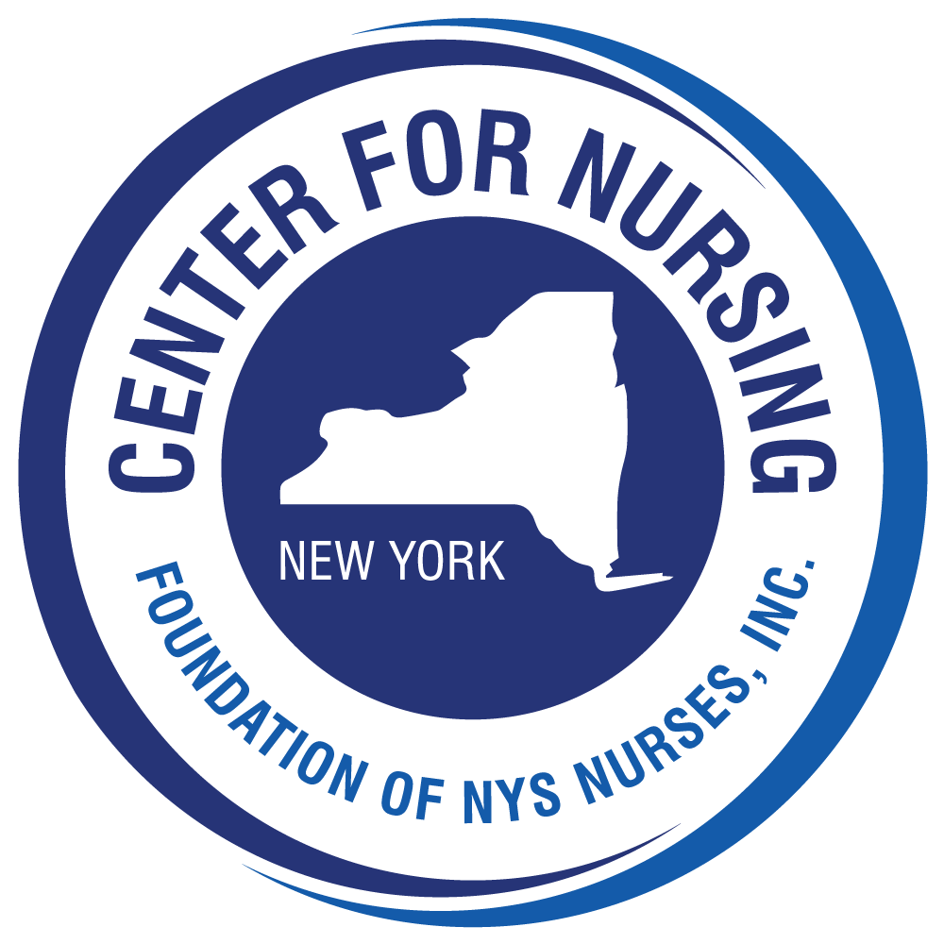

Mary J. Finnin Grant
for Nursing Innovation in Oncology

Letter of Recommendation

Applicant name_____________________________________________________

Your name ________________________________________________________

Relationship to the applicant__________________________________________________________

Position/Role_______________________________________________________

Organization/Institution_______________________________________________

Address___________________________________________________________

Telephone: Work_______________________ Home/Cell ___________________

Comments: ________________________________________________________

__________________________________________________________________

__________________________________________________________________

__________________________________________________________________

__________________________________________________________________

__________________________________________________________________

Signature__________________________________________________________

Mary J. Finnin Grantee Project Progress Report

Name: ____________________________________________

Date of Progress Report: _____________________

Year of Grant Award: _____________

Title of Project: ______________________________________________________________

Please provide a brief summary of the project activities completed to date.

___________________________________________________________________________

___________________________________________________________________________

___________________________________________________________________________

___________________________________________________________________________

___________________________________________________________________________

Please provide a line item expenditure summary for the project grant that shows how the funds were spent, amount expended, and date(s) of expenditure(s).

ACTIVITY | AMOUNT | DATE | COMMENTS/EXPLANATION

Committee Evaluation Form (for your information only)

 |  |  | Yes | No | N/A
Purpose of the project | Consistent with the intent of the grant
Significance of the project | Significant to the nursing profession
Review of literature | Related to and supports the current project
Purpose statement | Clear, logically emanates from the literature
Project method | Appropriate for the project purpose
Method(s) for evaluating effectiveness | Practical and feasible
Budget narrative | Well defined
Line-item budget | Realistic/appropriate
Appendices | Appropriate, applicable and complete

Comments: ____________________________________________________________

_______________________________________________________________________

_______________________________________________________________________

_______________________________________________________________________

