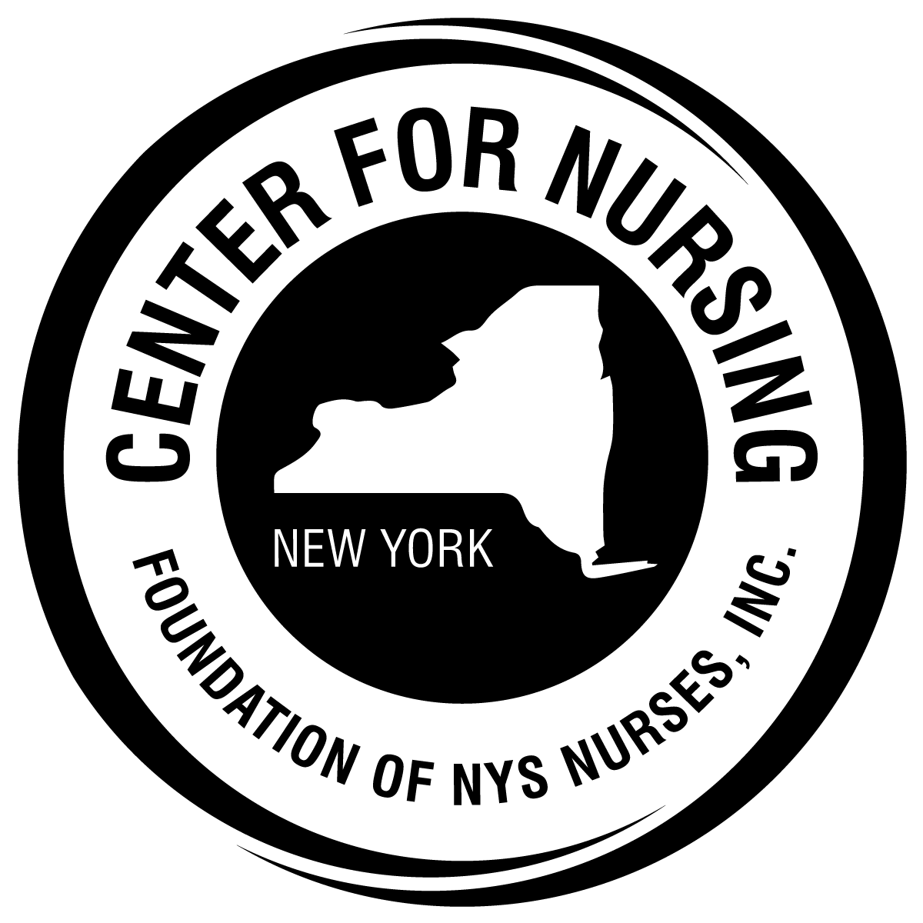

FOUNDATION of NEW YORK STATE NURSES
CATHRYNE A. WELCH
CENTER FOR NURSING RESEARCH

APPLICATION PACKET
For
The Noah Tubbs Family Trust
Nursing Research Grant
This grant is offered annually on a rolling basis.

This packet may be downloaded from the Foundation web site.
Widespread dissemination is encouraged and deeply appreciated.

Foundation of New York State Nurses

Central New York Nurses Center for Nursing Research

Veronica M. Driscoll Center for Nursing
2113 Western Ave., Suite 1
Guilderland, NY 12084
Tel: 518-456-7858
Fax: 518-452-3760
www.FoundationNYSNurses.org
e-mail: mail@FoundationNYSNurses.org
Table of Contents

Introduction and Instructions for Applicants Page 3

Eligibility and Use of Grant Funds Page 3

Applicant Eligibility Page 3

Appropriate Use of Grant Funds Page 4

Evaluation Criteria Page 4

Application Requirements and Grant Award Dates Page 6

Checklist Page 6

Grant Review Process Page 6

Awardee Responsibilities Page 6

Applicant Information Sheet Page 7

Budget Form Page 8

Reference Form Page 9

Research Progress Report Page 10

Committee Evaluation Form Page 11

FOUNDATION OF NEW YORK STATE NURSES

Cathryne A. Welch Center for Nursing Research
The Noah Tubbs Nursing Research Grant

Introduction and Instructions for Applicants
The Foundation’s Cathryne A. Welch Center for Nursing Research aims to improve nursing science and practice by supporting the conduct of nursing research and dissemination of research findings. The Center takes great pride in offering The Noah Tubbs Family Trust Nursing Research Grant.
The funding for this grant is made possible by the Noah Tubbs Family Trust Fund bestowed upon the Foundation of New York State Nurses, Inc. by Adelaide Margaret Tubbs in honor of Noah Tubbs, Lillian Tubbs, Noah T. Tubbs, Jr., Lillian Augusta T. Roauer, Pearl Clementine Tubbs and Adelaide Margaret Tubbs. These funds are given in memory of Mildred Montag, professor and visionary, and Ida MacDonald of Syracuse University, advisor, professor and friend of Adelaide M. Tubbs.
The Noah Tubbs Family Trust Nursing Research Grant

Award Intent: To assist qualified registered professional nurses to pursue nursing research. Special consideration will be given to nurses pursuing research in the field of geriatrics.
Amount of Award: Total amount awarded on an annual basis is $10,000.

Eligibility and Use of Funds
To be eligible to apply for The Noah Tubbs Family Trust Nursing Research Grant, the applicant must:
- Hold licensure as a registered professional nurse in New York State;
- Have a baccalaureate or higher degree in nursing from a nursing program accredited by the Accreditation Commission for Education in Nursing (ACEN) or the Commission on Collegiate Nursing Education (CCNE);
- Reside in and/or practice professional nursing in New York State;
- Approved awardees may apply for one subsequent grant. Applicants who are denied are eligible to reapply.
Preference will be given to professional nurses who 1) show they have a research mentor available to assist with the project (e.g., nursing research faculty or a nursing research consultant), or 2) have prior nursing research experience.

Examples for Use of Grant Funds

- Researcher time, expenses for research assistants (e.g., tape transcription)
- Travel expenses incurred while collecting data
- Photocopying
- Postage
- Equipment to support the data collection process (e.g., tapes, tape recorder)
- Participant reimbursement
- Poster development

Evaluation Criteria
Grant proposals will be evaluated on three criteria:
- the quality of the research proposal.
- the extent to which the proposal matches the intent of The Noah Tubbs Family Trust Nursing Research grant (see page 3, Award Intent).
- the need for financial support for the proposed study.
Applicants are requested to follow the outline below when submitting a proposal for consideration. The evaluation criteria for each section are described where applicable. Please note that Section II and III should not exceed 10 pages, double spaced.
Section I: Applicant Information Sheet (pg. 7)
Section II: Project proposal or IRB approval
- Title of Study
- Purpose (aims) of the study. This section should also include a statement that describes how the proposed research is consistent with the intent of The Noah Tubbs Family Trust Nursing Research Grant;
- Significance of the research to the nursing profession. Clearly indicate how this project will impact the profession of nursing in New York State and/or the health and well-being of the population;

- Review of literature. Briefly summarize relevant literature that supports the research project;

- Research questions and hypothesis. The research questions and hypotheses should be clear, concise, and emanate from the review of literature;

- Research design and method. Describe the study design and methods. Both the research design and methods should be appropriate for the research question. Validity and reliability of the research instrument(s) should be addressed if applicable.
Section III: Human Subject Protection. Describe the procedures for protecting human subjects. (Note: Letters of Institutional Review Board (IRB) approval and/or other relevant materials should be included in an appendix. An example would be IRB application for the institution who will not review before funding.)

Section IV: Budget
- Budget narrative: Include a brief justification for how the funds will be used (e.g., to support transcription, copying, postage).

- Budget Form: Please complete the attached budget form (pg. 8). [Note: this form may be adapted to meet the specific needs of your project.]
Section V: Appendices (Will contribute to the overall quality of the proposal)
A. Research Instruments (if applicable)
B. Consent forms (if applicable)
- Letter from authorized IRB documenting approval of the proposed research (if applicable)
- Letter(s) of agency agreement (if applicable).
- A letter of Recommendation (pg. 9)
- Applicant’s Curriculum Vitae or resume (required)
- Copy of current nursing registration

Application Requirements and Grant Award Dates

Applicants are required to submit one completed hard copy application with signatures and one application electronically to the Foundation. Applications should be submitted to:
Deborah Elliott, MBA, BSN, RN
Executive Director
Foundation of New York State Nurses
2113 Western Avenue Suite 1
Guilderland, NY 12084
delliott@cfnny.org

Grant funds will be available at the onset of the project.

Checklist
Have you:
- Completed the Applicant Information Sheet
- Followed all directions for each section of the Application – including the page limit
- Completed the Budget Form

Grant Review Process
Review

Grant applications are evaluated by a panel of professional nurses with expertise in nursing practice, education, administration, and research.

Awardee Responsibilities
As a condition of releasing the approved grant funds, the awardee must agree, in writing, to these terms:
- Provide a written description of the research and its outcomes for use in Foundation publications.
- Acknowledge the Foundation grant funding in all publications and presentations about the research. The Foundation suggests this acknowledgement statement: “This study was supported by funds from the Foundation of the New York State Nurses. Study findings and conclusions are those of the author and do not reflect the official position or views of the Foundation.”
- Complete and submit the attached Research Progress Report (pg.11).

Applicant Information Sheet
Name of applicant:
Address:

Day time phone number: (___)__________ Evening phone number: (___)
Fax number: (____)___________ E-mail address:
NYS Professional Registered Nurse License Number:
Credentials held:

Highest degree completed: __________________________________

Are you currently enrolled as a student?
- No
- Yes - If yes, please complete the following information:
Institution:
Degree sought: ______________________________
Expected date of graduation: ___________________

Employer: ___________________________________________________________

Preferred Mailing Address:

Expected completion date: ____________________________________

Budget Form

Category | Amount Requested from the Foundation | Amount Requested or Received from Other Sources | Total Amount Requested for the Study
Personnel Services (please list each one separately)
Travel
Photocopying
Participant reimbursement
Postage
Poster development
Other (please describe)
Total

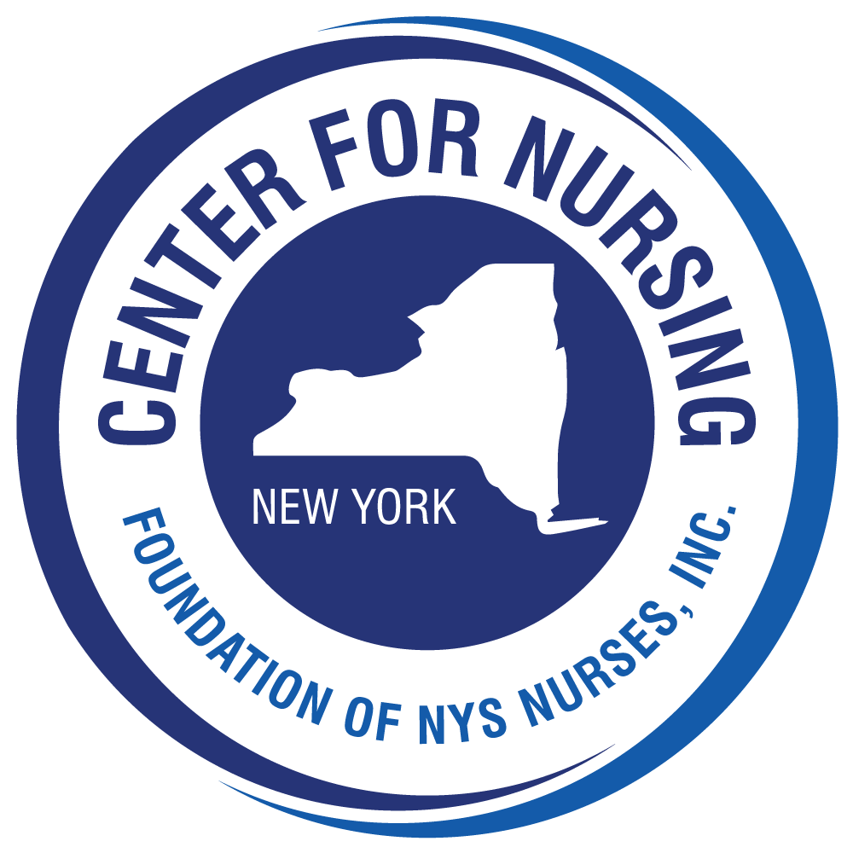

The Noah Tubbs Family Trust Nursing Research Grant
Reference Form

Applicant name_____________________________________________________

Name of reference provider_____________________________________________

Relationship to the aapplicant_______________________________________________________

Position_________________________Organization/Institution_____________

Address_______________________________________________________

Telephone: Work_______________________ Home/Cell _______________

- On a separate sheet of paper, please describe how in your relationship with the applicant you were able to assess/observe their aptitude for pursuing nursing research.
- Please rate the applicant on the characteristics listed below using a scale with 5 being the highest and 1 being the lowest.

 | 5 | 4 | 3 | 2 | 1
Leadership
Character/Integrity
Accountability/Dependability
Communication Skills/Oral and Written
Problem Solving/Judgment
Interpersonal Skills
Intellectual Potential
Creativity/Vision

Grantee Research Progress Report

Name: ____________________________________________________________________

Address:___________________________________________________________________

__________________________________________________________________________

Date of Progress Report: ____________________

Year of Grant Award:________________

Title of Research:__________________________________________________________

Please provide a brief summary of the research activities completed to date.

_________________________________________________________________________

_________________________________________________________________________

_________________________________________________________________________

_________________________________________________________________________

Please provide a line item expenditure summary for the research award that shows how the funds were spent, amount expended, and date(s) of expenditure(s).

ACTIVITY | AMOUNT | DATE | COMMENTS/EXPLANATION

Committee Evaluation Form (for your information only)

Purpose of the study | Consistent with the intent of the award |  | Yes | No | N/A
Significance of the study | Significant to the nursing profession
Review of literature | Related to and supports the current study
Research questions | Clear, logically emanate from the literature
Research design | Appropriate for the study question(s)
Research method | Appropriate for the design and/or question(s)
Human subjects | Well documented
Budget narrative | Well defined
Line-item budget | Realistic/appropriate
Appendices | Appropriate, applicable and complete

Comments: ____________________________________________________________

______________________________________________________________________

______________________________________________________________________

_______________________________________________________________________

