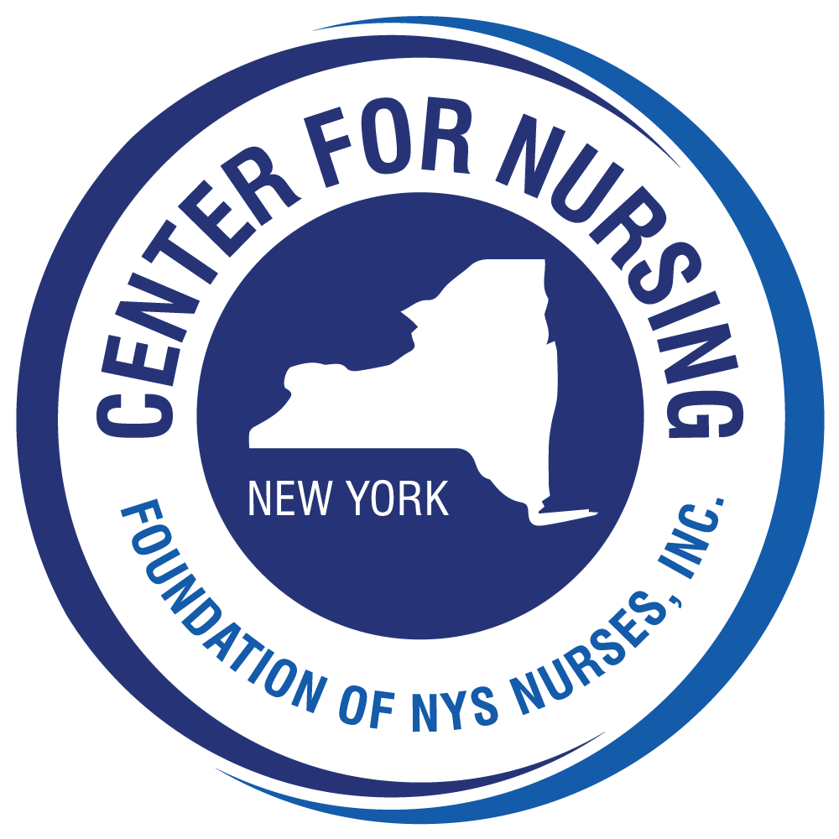


Dear Colleagues,

Since 1980, the Foundation of New York State Nurses has sponsored a program to recognize nurse researchers who conduct studies that contribute to the advancement of nursing and patient care. This program fulfills the Strategic Plan goal of the Cathryne A. Welch Center for Nursing Research to recognize outstanding nursing research in New York. Since its inception, thirty-four Distinguished Nurse Researchers (DNR) have been recognized. These scholars have created a legacy of leadership and scholarship which continues to inspire programs of nursing research.

The accompanying packet provides you with the eligibility and nomination requirements for the Distinguished Nurse Researcher Award as well as an outline of the review criteria and process. If you have questions, please do not hesitate to contact Susan Seibold-Simpson at the Cathryne A. Welch Center for Nursing Research (research@cfnny.org). We encourage you to nominate a colleague and to share this information with others whose work may qualify. Self-nominations are welcome. We thank you for your consideration of the Award program and your interest in nursing research.

For your information I have attached the names of previous awardees.

Sincerely,

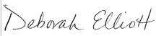

Deborah Elliott, MBA, BSN, SRN
Executive Director

Center for Nursing
Foundation of New York State Nurses
2113 Western Ave.
Guilderland, NY 12084
(518) 456-7858 ext. 29
www.cfnny.org

Previous Nursing Research Awardees

DISTINGUISHED NURSE RESEARCHERS

2017 Hyekyun Rhee, PhD, RN, PNP, FAAN
2015 Veronica Feeg, PhD, RN, FAAN
2013 Deborah A. Chyun, PhD, RN, FAHA, FAAN
2011 Ann Kurth, PhD, CNM, FAAN
2010 Nancy M. Watson, PhD, RN, FGSA
2009 Gail D’Eramo Melkus, EdD, MS, ASN/BS
2008 Patricia W. Stone, PhD, RN
2007 Mary W. Byrne, PhD, RN, FAAN
2006 Carol S. Brewer, PhD, RN
2006 Hong Li, PhD, RN
2005 Keville C. Frederickson, EdD, RN, FAAN
2004 Dianne Morrison-Beedy, PhD, RNC, WHNP
2003 Joyce K. Anastasi, PhD, RN, FAAN, LAc
2002 Jean K. Brown, PhD, RN, FAAN
2001 Margaret Lunney, PhD, RN, CS
2000 Bernadette M. Melnyk, PhD, RN-CS, PNP
1999 Sandra Graham McClowry PhD, RN, FAAN
1998 Lillie M. Shortridge-Baggett, EdD, RN, FAAN
1997 Judith Gedney Baggs, PhD, RN
1996 Terry T. Fulmer, PhD, RN, FAAN
1995 Elizabeth A.M. Barrett, PhD, RN, FAAN
1994 Christine T. Kovner, PhD, RN, FAAN
1993 Kathleen B. King, PhD, RN
1992 Susan E. Pollack, PhD, RN, FAAN
1991 Bethel A. Powers, PhD, RN
1990 Ellen M. Baer, PhD, RN
1989 Thelma J. Wells, PhD, RN, FAAN, FRCN
1988 Madeline H. Schmitt, PhD, RN, FAAN
1987 Wanda C. Hiestand, EdD, RN
1986 Marlene Ventura, EdD, RN, FAAN
1983 Marilyn T. Oberst, EdD, RN
1982 Carol N. Hoskins, PhD, RN
1981 Jean E. Johnson, PhD, RN
1980 Judith A. Sullivan, EdD, RN

Foundation of New York State Nurses
Cathryne A. Welch Center for Nursing Research

2024 Distinguished Nurse Researcher Award
Nomination Packet
Nominate yourself or a colleague for the Foundation of New York State Nurses 2024Distinguished Nurse Researcher Award
*****************************************************************************************
The Foundation of New York State Nurses Cathryne A. Welch Center for Nursing Research invites nominations, including self-nominations, for the Distinguished Nurse Researcher Award. This award, sponsored by the Foundation of New York State Nurses, is designed to recognize excellence in nursing research.

Criteria for the award include:
- Evidence of a coherent research program;
- Evidence of leadership in health care research;
- Quality of research;
- Contribution to the science and art of nursing and health care; and
- Dissemination of research to the scientific and clinical communities.

Distinguished Nurse Researcher
- Registered professional nurse licensed in New York who is doctorally prepared and has obtained at least one degree, either baccalaureate or higher in nursing;
- Has data-based publications in peer reviewed journals/publications which demonstrate a coherent research program;
- Demonstrates quality and leadership in health care research which contribute to the science and art of nursing and health care;
- Disseminates the findings of her/his research to the scientific and clinical communities;
- As principal investigator, has consistently received substantial funding since completion of the doctorate.

Nominations and supporting documents must be sent electronically by April 18, 2024

The Nomination Packet for the Distinguished Nurse Researcher Award consists of the following forms:
- Instructions for Nominators
- Nominator’s Form
- Instructions for Supporting References
- Nominee Instructions
- Nominee’s Personal Statement
6. Review Criteria for Award (for informational purposes only)
Foundation of New York State Nurses
Cathryne A. Welch Center for Nursing Research
2024 Distinguished Nurse Researcher Award

Instructions for the Nominator

- Secure the nominee’s permission to submit her/his name in nomination for the Distinguished Nurse Researcher Award.
- Complete and sign the Nominator’s Form. Please submit an electronic copy to research@cfnny.org as early as possible. This will enable us to monitor the number of nominations.
- Give the nominee the Nominee Instructions and the Nominee Personal Statement Form for completion.
- Distribute Reference Forms to two (2) other individuals who are willing to sponsor this nomination.
- A completed packet of one electronic copy with signatures should be submitted by April 18, 2024 to:

Susan Seibold-Simpson, PhD, MPH, RN, FNP
Research Specialist
Cathryne A. Welch Center for Nursing Research
research@cfnny.org

Note: the nomination is not complete until all forms of the application packet are received.

After the Nomination Packets are received, members of the Foundation of NYS Nurses Cathryne A. Welch Center for Nursing Research Scholarship, Awards and Applications subcommittee will review the nominees and submit their recommendation(s) for the 2024 Awardee to the Foundation of NYS Nurses Board of Directors. The Foundation Board of Directors will make the final decision on the awardee. For additional information or questions please contact Susan Seibold-Simpson, Research Specialist at research@cfnny.org
.

Thank you for submitting this nomination!
THE FOUNDATION OF NEW YORK STATE NURSES
Center for Nursing Research
2024 Distinguished Nurse Researcher Award

Nominator’s Form

Name of Nominee____________________________________________________

- Using the five criteria for this award, and the definition of eligibility, please state why you think the nominee (or self) should be considered for the Distinguished Nurse Researcher award. (Please limit to 3 pages.)

- Please list the names, titles, and addresses of the two individuals providing references for this nominee (or self).

- Nominator’s Information

Signature_____________________________________________Date____________

Name_________________________________________________________________

Title/position__________________________________________________________________

Address_______________________________________________________________

______________________________________________________________________

______________________________________________________________________

Telephone
Work ____________________________; Other________________________________

Email_________________________________________________

THE FOUNDATION OF NEW YORK STATE NURSES
Cathryne A. Welch Center for Nursing Research
2024 Distinguished Nurse Researcher Award

Instructions for Individuals Submitting References

Thank you for being willing to provide a reference for ______________________________________ who has been nominated for the Foundation of New York State Nurses Distinguished Nurse Researcher Award. The criteria for the award are:

- Evidence of coherent research program;
- Evidence of leadership in health care research;
- Quality of research;
- Contribution to the science and art of nursing and health care; and
- Dissemination of research to the scientific and clinical communities.

Please comment, in 1-2 pages, on the significance of the nominee’s research contribution to nursing in light of the stated criteria. Please sign and date this reference. The statement should be submitted electronically by April 18, 2024 to Susan Seibold-Simpson at research@cfnny.org

For additional information about the Distinguished Nurse Researcher Award, please visit www.cfnny.org

Thank you for contributing to this nomination!

Foundation of New York State Nurses
Cathryne A. Welch Center for Nursing Research
2024 Distinguished Nurse Researcher Award

Nominee Instructions

Congratulations on your Nomination for the 2024 Distinguished Nurse Researcher Award! Nominees for the Distinguished Nurse Researcher Award, given biennially by the Foundation of New York State Nurses, must demonstrate:
- Evidence of a coherent research program;
- Evidence of leadership in health care research;
- Quality of research;
- Contribution to the science and art of nursing and health care; and
- Dissemination of research to the scientific and clinical communities.

For additional information about the Distinguished Nurse Researcher Award, please visit www.cfnny.org

As a nominee, we request that you submit the following supporting documentation of your eligibility for the award:

- Complete and sign the attached Nominee’s Personal Statement Form;
- Submit reprints or copies of three (3) articles that are representative of the scope of your published research;
- Attach your curriculum vitae emphasizing your research contributions by placing a checkmark or asterisk by each publication that is available through an electronic search.

Please submit an electronic copy of the form and the above documents by April 18, 2024 to research@cfnny.org

For questions, please contact:
Susan Seibold-Simpson, PhD, MPH, RN, FNP
Research Specialist
Foundation of New York State Nurses
The Veronica M. Driscoll Center for Nursing
2113 Western Avenue
Guilderland, New York 12084
research@cfnny.org

Congratulations on your nomination!
THE FOUNDATION OF NEW YORK STATE NURSES
Cathryne A. Welch Center for Nursing Research
2024 Distinguished Nurse Researcher Award

NOMINEE’S PERSONAL STATEMENT

(Please limit to 5 pages)

1. I have been or am presently involved in the following research activities:

2. My major contributions to nursing knowledge and nursing research have been:

************************************************

By returning these materials, I accept the nomination for the Distinguished Nurse Researcher Award and grant the Foundation Center for Nursing Research the right to review these and all other materials pertaining to my nomination. If chosen, I am willing to present at a meeting to be determined by the Foundation of New York State Nurses.

Signature________________________________________________Date__________

Name_________________________________________________________________

Mailing Address________________________________________________________

______________________________________________________________________

Telephone: (Please indicate preferred method for contact)
Home:_______________________________ Work:___________________________

E-mail Address__________________________________________________________

THE FOUNDATION OF NEW YORK STATE NURSES
Cathryne A. Welch Center for Nursing Research
Distinguished Nurse Researcher Award

CRITERIA FOR DISTINGUISHED NURSE RESEARCHER AWARD
For information only – do not complete

CRITERIA | EVIDENCE
1. Evidence of coherent research program | 1. Studies related  2. Consistent pattern of inquiry
2. Evidence of leadership in health care research | 1. Role  a. Principal investigator  b. Co-investigator  c. Facilitator of research (e.g, mentor, consultant)  2. Funding  a. Federal  b. Major foundation  c. Other
3. Quality of Research | 1. Clear conceptual basis  2. Valid methods  3. Logical conclusions
4. Contribution to the science and art of nursing and health care. | 1. Adds to the body of knowledge  2. Enhances clinical practice
5. Dissemination of research to scientific and clinical communities | 1. Published  a. Articles  1. Data based research  2. Theory development  3. Clinical application of research  4. Primary author  5. Co-author
b. Journals
1. Refereed
2. Prestigious research
3. Prestigious clinical
4. Prestigious issues
c. Books
1. Synthesis of research and theory
2. Clinical application of research and theory
3. Sole author
4. Co-author
5. Sole editor
6. Joint editor
2. Presented
a. Regional meetings
b. National meetings
c. International meetings
d. Research, data-based
e. Research, non-data-based
f. Paper
g. Symposium
h. Poster
i. Webinar

