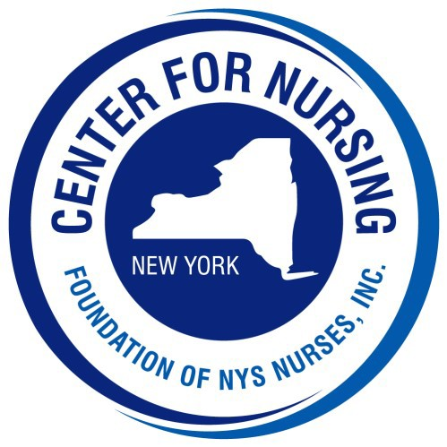
2026 Nightingale Gala

Tickets and Tables of 10

o $175 per person o $105 Young Professional (35 & Under) o $1,500 Table of 10

Name:
Address:
City: State: NY Zip:

Telephone #: Email:

Check Enclosed (made payable to Foundation of NYS Nurses, Inc.)

Please charge my credit card: Card # Exp: CVV:

Indicate names of guests on back of form

PLEASE REPLY by August 1, 2026

Please return this form with your payment to:
Center for Nursing at the Foundation of NYS Nurses, Inc., 2113 Western Avenue, Guilderland, NY 12084 Telephone (518) 456-7858 Fax (518)452-3760 Email: delliott@cfnny.org

Names of Guests

