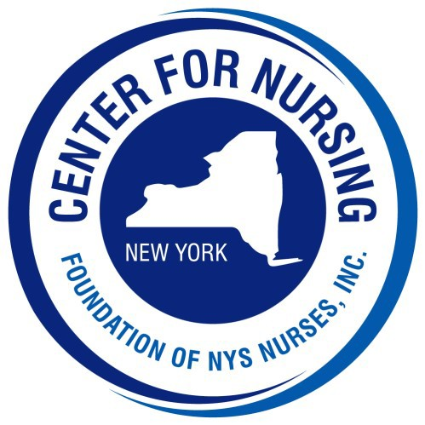
2026 Nightingale Gala

Tickets and Tables of 8

o $175 per person o $105 Young Professional (35 & Under) o $1,250 Table of 8

Name:
Address:
City: State: NY Zip:

Telephone #: Email:

Check Enclosed (made payable to Foundation of NYS Nurses, Inc.)

Please charge my credit card: Card # Exp: CVV:

Indicate names of guests on back of form

PLEASE REPLY by August 28, 2026

Please return this form with your payment to:
Foundation of NYS Nurses, Inc.
26 Country Fair Ln.
Glenville, NY 12302
Telephone (518) 339-2341
delliott@cfnny.org

Names of Guests

