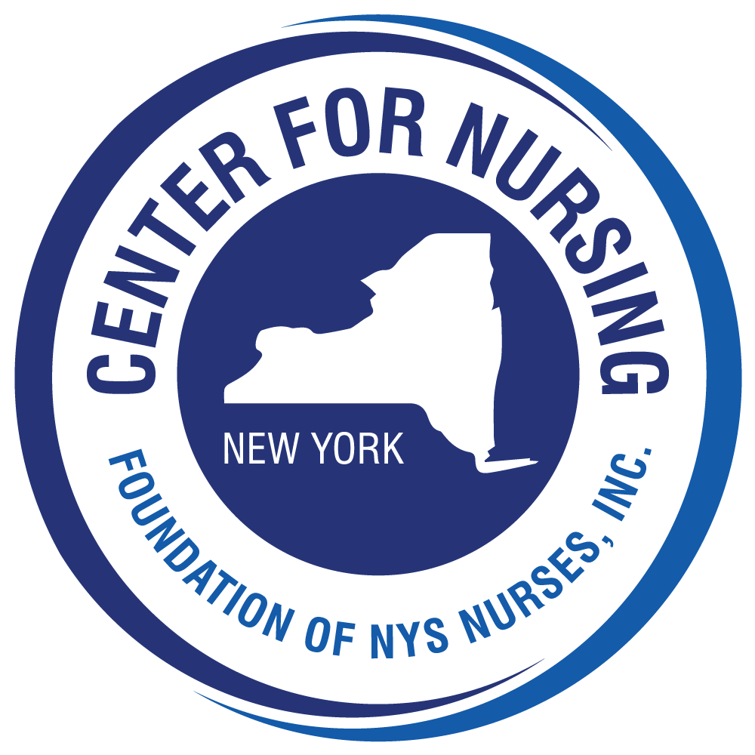
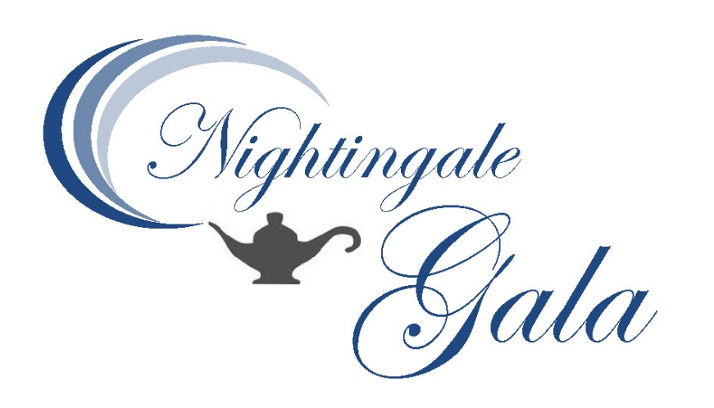
Friday, November 13, 2026
Hilton Garden Inn
Troy, NY 12180

Help Us Celebrate
New Beginnings for the
Foundation of NYS Nurses, Inc.

Sponsorships, Program Ads, Tables of 8 & Tickets ($175 each) available!
Contact Deb Elliott delliott@cfnny.org

