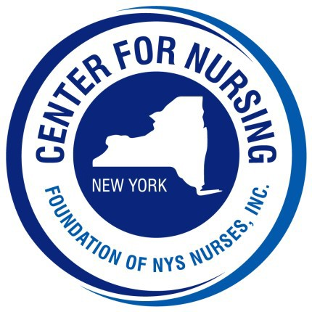
2026 Nightingale Gala
Program Ad Form

Place an ad honoring:

The 2026 awardees, an exemplary nurse or to promote your business

Ad Deadline: Friday, August 28, 2026

1/4 Page
2.25” x 3.75”
$75

1/2 Page
4.75” x 3.75”
$125

Full Page
4.75” x 7.75”
$250
Inside Cover
(Front / Back)
$500
Back Cover
(Outside)
$650

Organization / Business: Contact: Address: City: State: Zip: Telephone #: ________________Email: _____
Check Enclosed (made payable to Foundation of NYS Nurses, Inc.)
Please charge my credit card: Card # Exp: C VV:

Please return this form with your payment to:
Foundation of NYS Nurses, Inc.
26 Country Fair Ln. Glenville, NY 12302 Telephone (518) 339-2341
Prepared ads can be emailed to Deb at delliott@cfnny.org

