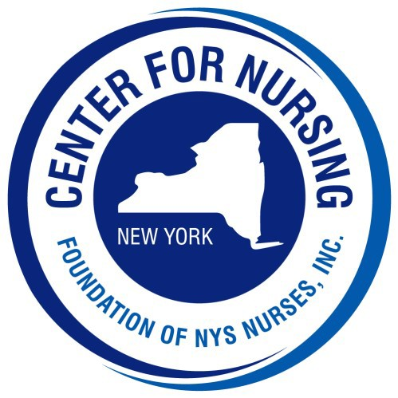

2026 Nightingale Gala

Sponsorship Form

[ ] Innovator* | $10,000 | - Includes two (2) tables of eight (8)and two virtual ads
[ ] Crafter | $ 5,000 | - Includes one table of eight (8) and full page virtual ad
[ ] Photography Sponsor* | $ 3,000 | - Includes six (6) tickets and full page virtual ad
[ ] Music Sponsor* | $ 2,000 | - Includes four (4) tickets and full page virtual ad
[ ] Cultivator | $ 1,500 | - Includes four (4) tickets and half page virtual ad
[ ] Curator | $ 500 | - Includes two (2) tickets and quarter page virtual ad

*These sponsorship levels are exclusive to one organization/business/individual
In order to be displayed on our website, displayed virtually the night of the event and recognized at the event. Sponsors must be submitted by July 1, 2026
Please check your sponsorship level above

Organization / Business: Contact: same
Address: . City: State: NY Zip: Telephone #: Email:
Check Enclosed (made payable to Foundation of NYS Nurses, Inc.)
Please charge my credit card: Card # Exp: CVV:

Please return this form with your payment to mail to:
Foundation of NYS Nurses, Inc. 26 Country Fair Lane, Glenville, NY 12302
Payments may be made online at www.cfnny.org. Please indicate it is for a Gala sponsor and email the sponsor form to delliott@cfnny.org

